**Chino Valley Family Chiropractic**



Julie Weston, D.C. and Anita Scheer, D.C.

1260 South Highway 89, Suite F

Tel: 928.636.8181

Fax: 928.636.5925

www.ChinoValleyChiro.com

**Adult New Patient Application**

WELCOME TO OUR OFFICE. WE THANK YOU FOR YOUR TRUST.

Please fill this form out in blue or black ink. Answer all questions. If a question doesn’t apply, please write NA on the line.



**SECTION 1: PATIENT INFORMATION**

Appointment Date_____________________________ Referred by_____________________________

Name (first, middle, last)_______________________________________ Preferred Name _________________

Address _____________________________________________ City______________ State_____ Zip_________

Date of Birth_______________ Age_____ Gender_______

Cell Phone___________________ Home Phone___________________ Work Number____________________

Social Security Number_________________________ Marital Status Married Single  Divorced Widowed

Email|______________________________________ May we utilize email for communication Yes No

Employer____________________________________ Occupation_____________________________________

Name of Spouse / Significant Other_________________________________

Emergency Contact____________________________ Relationship_________________ Phone__________________

Most practice members are referred to our office by a caring family member or friend. Who can we thank for your referral? Friend / Family Member Name___________________________ Other___________________

1. Research shows that your spine should be checked regularly. How many times have you visited a chiropractor in your lifetime? _____________________ Never

For what were you seen?_________________________________ Were you helped?  Yes No

1. When was your last complete spinal examination, including x-rays?____________________ Never
2. Have you been told you have a spinal curvature, spinal arthritis, or other spinal problems? Yes No
3. NeuroSpinal Dysfunction may cause decay and degeneration which results in grinding or crackling. Do you ever hear noise when you move your neck or spine? Yes  No
4. NeuroSpinal Dysfunction can make you feel like you need to twist, stretch, or crack your neck or back. Do you ever feel the need to crack or pop your neck or spine? Yes No
5. Poor posture leads to poor health and often indicates a NeuroSpinal problem. How would you rate your posture? Poor 1 2 3 4 5 6 7 8 9 10 Excellent
6. Stress can cause or accelerate spinal damage. Rate your stress level over the last 90 days.

Low 1 2 3 4 5 6 7 8 9 10 High

1. What is your motivation to seek / receive care in this office?___________________________________
2. Have you ever been diagnosed with cancer?  Yes No

If yes, where?___________________, what type?____________________ and when?_______________

1. Have you ever had spinal surgery? Yes No If yes, what type?__________________ and when?_____________
2. Spinal health is especially important during pregnancy. Is there a chance you are pregnant? Yes  No
3. What activities would you like to do that your health is impairing you from doing?

____________________________________________________________________________________________

1. How would your life change if you had optimal health?________________________________________________
2. What needs to happen for you to have optimal health and healing?______________________________________
3. If the doctor feels you will benefit from chiropractic care, are you willing to follow his/her recommendations?

❍ Yes  No

**SECTION 2: HISTORY OF CONCERN**

Primary Concern(s)

Secondary Concern(s)

Tertiary Concern(s)

Auto/work related injuries can cause serious spinal problems. Are your complaints due to an accident? Yes  No

If yes, what type  Work  Auto  Personal Date of accident

Have you reported this accident to anyone?  Yes  No Who was it reported to?

Have you seen any doctors for this condition?  Yes  No

Please list the doctor, specialty, and for how long you were seen

Prescription medications may cause various side effects, hide the severity of health problems and hinder the body’s ability to heal. What medications are you currently taking? (Prescription and non-prescription)

Medication For what condition Since when

**PLEASE MARK THE AREAS ON THE DIAGRAM WITH THE FOLLOWING LETTERS TO SESCRBE OUR SYMPTOMS:**

**R = Radiating B = Burning D= Dull A = Aching N = Numbness S= Sharp or Stabbing T = Tingling**

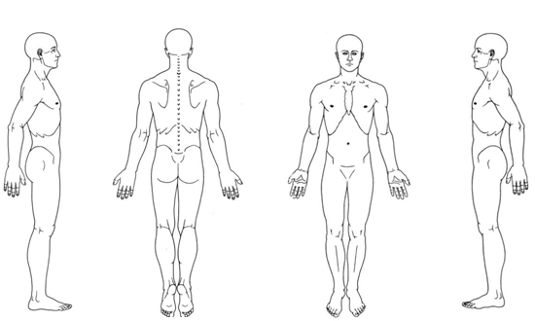

**SECTION 3: FAMILY HISTORY**

Does anyone in your family suffer with the same condition(s) or other chronic illnesses?  Yes  No

If yes, whom and what condition(s)

**Section 4: PAST TRAUMA HISTORY**

*Starting from birth, we all experience thousands of physical, mental and chemical stresses. These stresses can cause Postural Distortions (misalignments of the spine) and lead to our current health problems.*

Please write down some falls, injuries, and traumas that you’ve experienced. (Please put NA if it doesn’t apply)

1. **Car Accidents** (List even minor ones. A 5 MPH crash from a 3000lb vehicle can cause damage to your spine even if you didn’t ***feel*** injured!)

Date Type of Collision  Front Side Rear Speed Injuries

Date Type of Collision  Front Side Rear Speed Injuries

Date Type of Collision  Front Side Rear Speed Injuries

1. **Sports Injuries** (If there are too many to list, please write the name of the sport and “MANY” next to it)

Date Type of Sport Injuries Left  Right

Date Type of Sport Injuries Left  Right

Date Type of Sport Injuries Left  Right

1. **Slips, Falls and Bike Accidents** (We understand there may have been a lot of slips and falls since birth, so please list the major ones.)

Date Type of Injury Left  Right

Date Type of Injury Left  Right

Date Type of Injury Left  Right

1. **Repetitive Injuries** (Please list all repetitive injuries you’ve had in the past. For example: lifted heavy box, moved furniture, overhead working)

Date Type of Injury Left  Right

Date Type of Injury Left  Right

Date Type of Injury Left  Right

**SECTION 5: PRESENT AND PAST CONDITIONS**

**Your Nerve system controls and coordinates all of the organs, systems and functions of your body. It is protected by**

**your spine and your skull, if you have had an injury to your head or spine, no matter how “minor” it may have been,**

**it may have caused a health problem.**

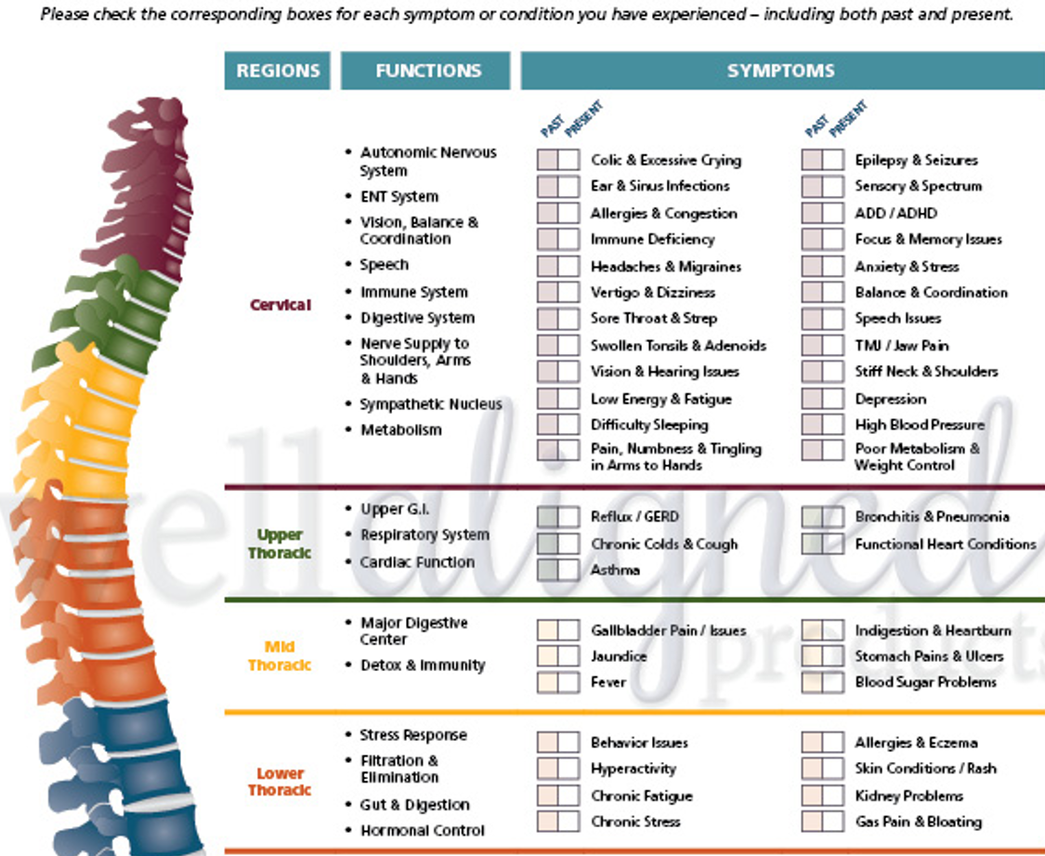

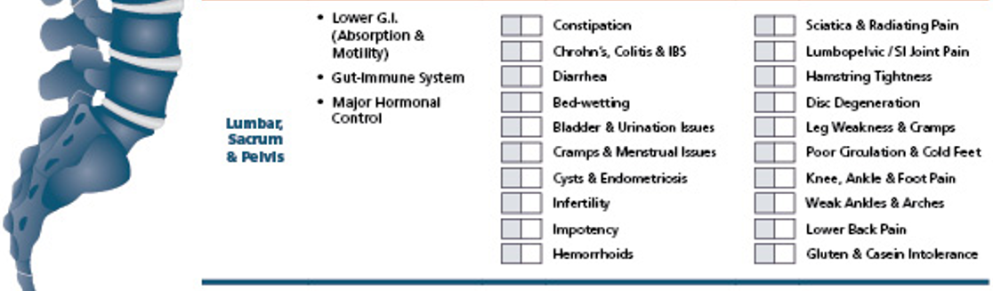

**SECTION 6 PAST HEALTH CONCERNS**

**Transfer any conditions you marked as a past health issue from the previous section (Section 5)**



Are any of these past conditions due to an accident?  Yes  No

If yes, what type  Work  Auto  Personal Date of accident

Have you seen any doctors for this condition?  Yes  No

Please list the doctor, specialty, and for how long you were seen

**List any past hospitalizations and/or surgeries**

|  |  |  |  |
| --- | --- | --- | --- |
| **Surgery / Hospitalization** |  |  | **When** |
|  |  |  |  |
|  |  |  |  |
|  |  |  |  |
|  |  |  |  |
|  |  |  |  |
|  |  |  |  |
|  |  |  |  |
|  |  |  |  |
|  |  |  |  |
|  |  |  |  |
|  |  |  |  |

The above information is true and accurate to the best of my knowledge. Copies of any x-rays and reports will be released upon

Written request, however original x-rays will remain the property of the clinic. I have been informed that the evaluation is not

For neuromusculoskeletal conditions or the evaluation of presenting complaints, but for spinal and neurological functional

capacity, spinal alignment and presence of spinal subluxation. Procedures recorded represent the limited evaluation procedures

chosen to assess this patient. Appropriate consent documents have been signed to proceed.

Patient/Guardian’s Signature Date